JOB ROLE
Project Producer
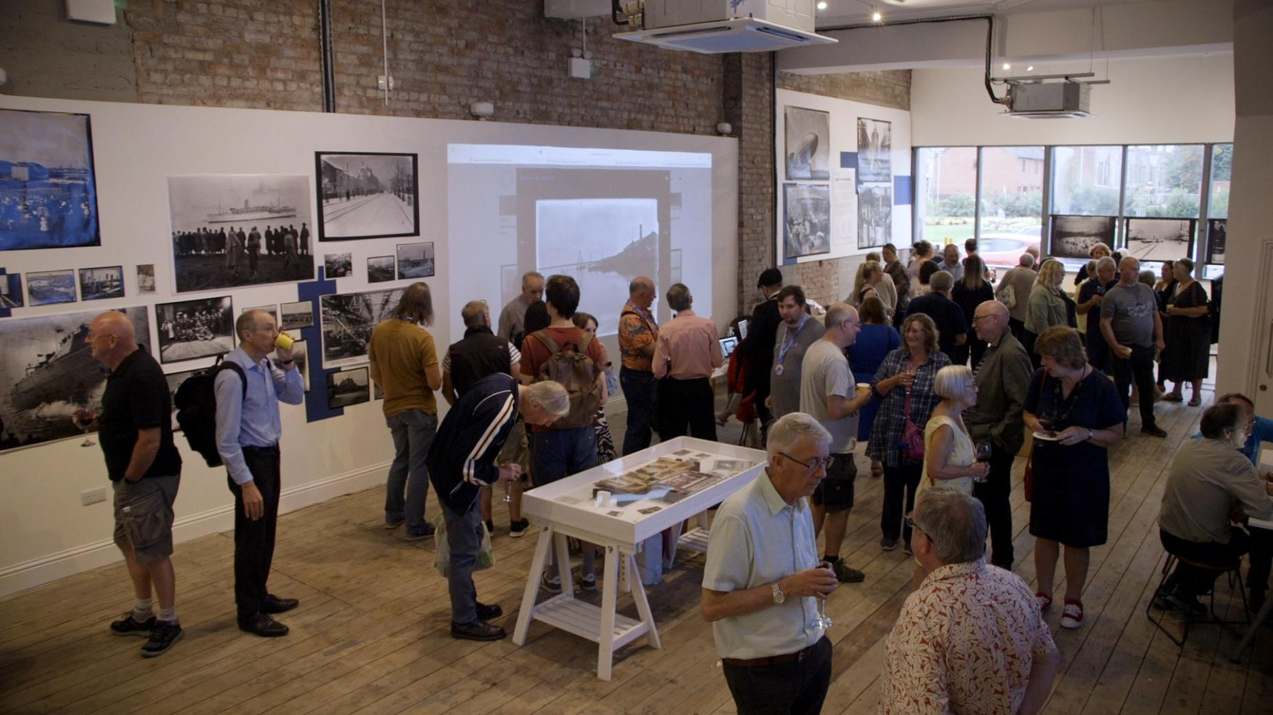

Salary: £28,000 (Pro rata) for 2-year Fixed Term Contract

Hours: Part time, 3 days (22.5 hours) initial two-year contract

Benefits: 35 days per year holidays (including bank hols & personal wellbeing days) pro rata’d

Location: Cooke’s Studios, 102-104 Abbey Road, Barrow -in-Furness, LA14 5QR/Remote Working

Reports to: Programme Manager

Direct Reports: Community Connector

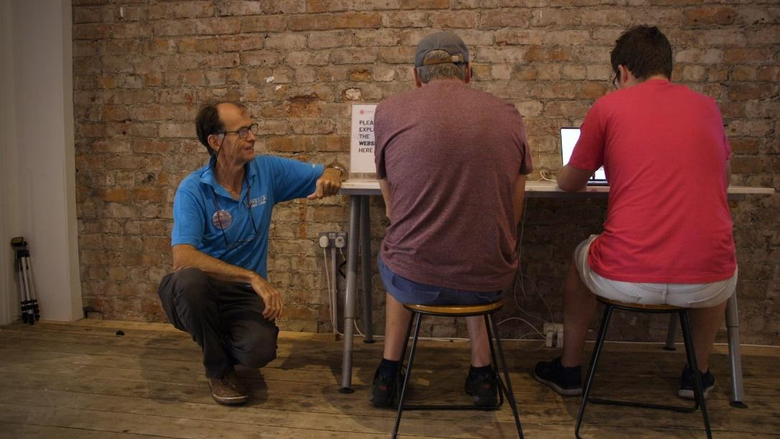
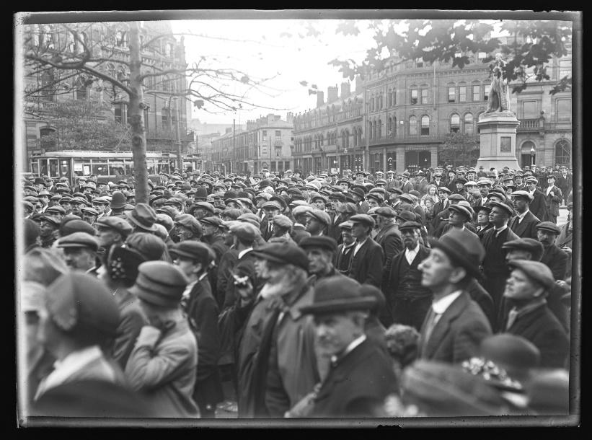
Are you passionate about expanding access to culture and heritage? Do you thrive on engaging with communities to fulfil their creative aspirations? We are looking for a multi-talented Project Producer who has a passion for making arts, cultural and heritage activities more engaging, accessible & inclusive.

Signal Film & Media
We are an award-winning digital arts charity using inspirational creative digital media experiences to enhance the lives of people living in Barrow-in-Furness & Cumbria. We believe in the power of creativity as a driver for social change and have a deep commitment to our vision of ‘A Cultural Community where Talent is Nurtured and People Thrive’. We offer an outstanding,year-round programme of inspirational heritage and digital arts learning opportunities, which support people at the margins of our community to reach their potential.

The Sankey Photographic Collection
The Sankey Photographic Collection is a collection of over 15,000 glass plate negatives and postcards, created by father and son duo Edward and Raymond Sankey, who documented Victorian and Edwardian Barrow-in-Furness, and Cumbria more widely, over an 80-year period. Now digitised and catalogued through our first project phase; ‘Seeing the North with Sankey’, the collection’s staggering breadth and its fantastic potential as a dynamic engagement tool is our inspiration and focus for this second phase - ‘Lives through the Lens’.

Primary Purpose of Role
‘Lives through the Lens’ is the second phase of heritage & arts engagement focusing on the unique and wonderful Sankey Photographic Collection. Funded by the National Lottery Heritage Fund, the project aims to engage underrepresented groups in the Sankey Collection through a program of training and creative interpretation projects.

As Project Producer, you will manage the overall ‘Lives through the Lens’ programme’, including planning, coordination, project delivery, monitoring, evaluation, and reporting. You will ensure the provision of high-quality heritage & cultural experiences with our communities, including workshops, training and exhibitions, and ensure we target and engage the most underrepresented and hardest to reach residents. You will work in partnership with a range of community & cultural groups and organisations to deliver a programme of training and interpretation projects that focus on the rich and dynamic stories of the Sankey Collection.

Key Duties & Responsibilities
Reporting to and supported by our Programme Manager, as Project Producer you will manage, coordinate, and deliver the ‘Lives through the Lens’ engagement project, within timeframes, on budget and achieving our key outcomes & outputs.
- Delivery of digital arts and heritage projects that comprise our ‘Lives through the Lens’ Programme, within timeframes, on budget and achieving outcomes/outputs.
- Coordinate the scheduling and delivery of all the project activities, including running the volunteer programme, training, and interpretation projects.
- Work collaboratively & in partnership with the local community, volunteers, cultural partners, community groups & organisations, and the wider Signal Film & Media team.
- Co-create a range of engaging, accessible, relevant, and inclusive digital arts and heritage activities.
- Build warm and supportive relationships with beneficiaries, colleagues, stakeholders and project partners.
- Liaise with, contract and support externally commissioned tutors, artists and cultural practitioners to ensure activities meet the desired outcomes.
- Effectively manage and develop our Community Connector.
- Create content for and oversee promotion of project activities in collaboration with our recruitment and marketing manager, including on Signal Film & Media’s website, across online networks and social media.
- Preparing and implementing appropriate monitoring and evaluation to track and report against project outputs and outcomes.
- Monitoring finances (Invoices and payments) related to ‘Lives through the Lens’ project.

Person Specification
- Confident in co-creating projects with participants from a wide range of backgrounds.
- Passion and enthusiasm for art, heritage, and creative/digital interpretation.
- An understanding and ability to articulate the value of arts, culture and heritage in our society and local community.
- A flexible and proactive approach to work, with the ability to work both independently and within a team as required.
- Dedication to making arts, cultural and heritage activities more engaging, accessible & inclusive.
- Commitment to compliance with safeguarding, health and safety and other policies.
- A willingness to work occasional evenings and weekends.

Skills and Experience
- Experience producing/project managing in an Arts, Museum, Gallery, Education or Community setting.
- Experience delivering engaging and creative learning activities and / or community initiatives.
- Experience working with community and cultural partners, artists and creative/cultural practitioners to deliver engaging, accessible activities.
- Ability to lead empowering, kind and productive outreach in community contexts including with diverse and hard to reach groups.
- Experience working in a fast-paced environment and reacting proactively to changing situations.
- Demonstrable experience of your marketing skills to engage new and hard to reach audiences across online networks, social media, and via community and local business groups.
- Ability to write compelling and comprehensive reports including interpreting evaluation data.
- Excellent interpersonal and communication skills.
- Excellent planning, organisational and administrative skills.
  - Good digital and IT skills.
  - An awareness of the importance of environmental sustainability, safeguarding, equality and diversity, privacy and following relevant legislation.
  - Desirable - Knowledge of, and passion for, photography.
  - Desirable - Experience of working with archives or collections.

Eligibility
- Applicants must have the right to work in the UK
- Anyone appointed will be subject to:
- A DBS check
- Reference checks
- Completion of safeguarding training and induction

HOW TO APPLY
For more information about the Job and How To apply please download and complete the application form at: https://signalfilmandmedia.com/about/work-with-us/ and return with a CV to info@signalfilmandmedia.co.uk OR email info@signalfilmandmedia.co.uk for an application pack.
Please include the job title in the subject line.
DEADLINE FOR APPLICATIONS: Midday on 5th Feb 2024
INTERVIEW DATES: 8th/9th or 12th/13th Feb 2024

